Counselling Young People:

A Humanistic and Integrative Approach to Working with Young People (11-18)

A five-day programme delivered over two workshops:
Days 1 - 3: Fri 22nd, Sat 23rd & Sun 24th March 2024 – Nottingham City
Days 4 & 5: Sat 20th & Sun 21st April 2024 – Nottingham City
Delivered by: Tim Woodhouse
Fees: Current SPTI students/ graduate members £320, non-SPTI members £350

This highly interactive and experiential workshop focuses primarily on the differences between working with adults and working with young people, helping you make the necessary cognitive and emotional adjustments between working with these two very different client groups. It is constructed on the very clear evidence-based competences that the BACP have identified and is designed to complement and extend the training offered in courses aimed at working with adults.

During the workshop we will investigate a number of key issues affecting young people today. Ten years ago, ‘family relationships’ were at the forefront of issues brought by young people to counselling. Today, anxiety and various forms of self-harming are the leading presenting issues. Also, we cannot ignore the ever-present influence of social media on this client group.

We will explore various methodologies that can be successfully used in working with young people. We know more than ever about the development of the adolescent brain. From this we are able to understand more about what adolescents are facing, and also more about how to engage them in the counselling relationship. We have long known that various creative approaches work more effectively with young people than traditional ‘talking therapies’ alone, and this workshop will explore some of these alternatives.

Working with young people presents legal and ethical considerations which are different from those encountered when working with adults. We will cover the key elements of professional and legal issues relevant to working with young people, including child protection and disclosure requirements, as well as notetaking and the wider legal system.

Finally, work with young people inevitably includes ‘others’ – parents, teachers, agency representatives, for example. We will explore the various contexts within which this work takes place and consider the particular implications of these for us as practitioners.

Throughout the workshop we will be reflecting back on our own experiences of adolescence and considering our wider experiences of and attitudes towards young people. This will help enhance our empathy with and ability to relate to our young clients.

Learning outcomes relating to working with young people aged 11-18:

- Understanding of the social, emotional and psychological development of young people

- Understanding issues affecting the psychological and emotional health of young people

- Knowledge of relevant legal frameworks, including confidentiality, consent and capacity, child protection and disclosure, and risk assessment

- Ability to operate within the relevant professional and ethical guidelines

- Ability to work in different contexts/settings

- Ability to communicate with young people of different ages and developmental stages

Available places
- Places are available on a first come, first served basis (please refer to the minimum entrance requirements).

Minimum entry requirements:
- Current BACP or UKCP Student Members (who have successfully completed all elements of year 1 of their respective training courses at level 4 or above)
- Graduates who have completed a BACP or UKCP diploma level counselling / psychotherapy qualification or equivalent, designed for working with adults

Please note: this course does not qualify you with BACP or UKCP to work with children and young people. However, it can provide a valuable resource for working with young people, aged 11-18, in placement or as professional development beyond training.

About the trainer: Tim Woodhouse
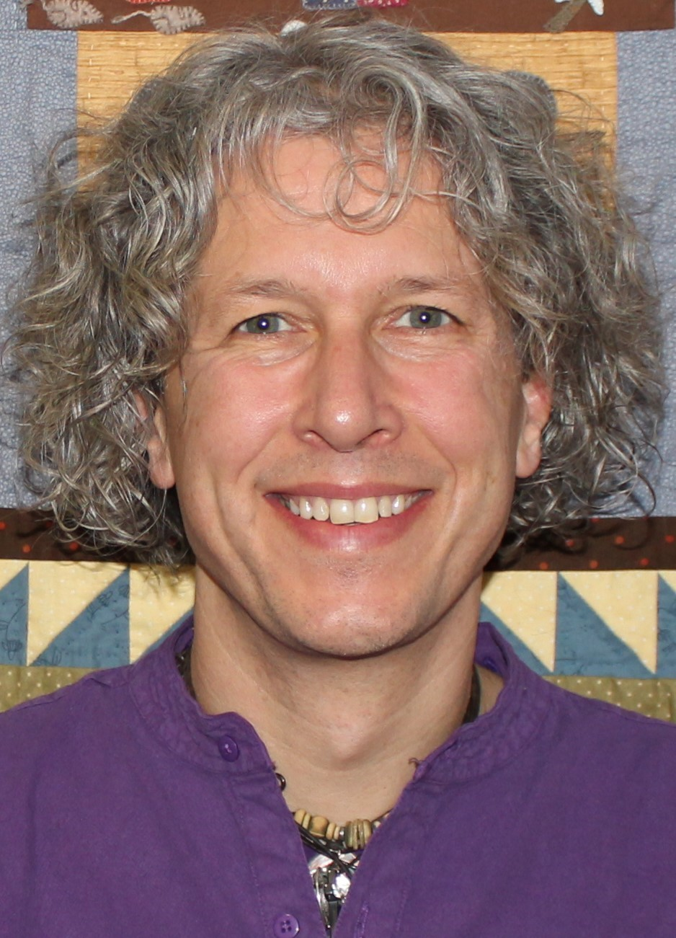
Tim has worked with children and families since 1984 and specifically in the field of sexual harm (sexual abuse, sexual assault, rape, children who sexually harm children and child sexual exploitation) since 1996. He is an advanced and certified Sensorimotor Psychotherapist, Enactive trauma therapist, registered Non-directive Play therapist, Filial therapist, EMDR Practitioner, Jungian and Integrative sand play therapist, an ABE approved Social Worker and is currently studying Internal Family Systems Therapy. He worked on the NSPCC child sexual abuse consultancy for 16 years where he co-founded the Hilton House attachment project and the St. Mary’s children’s sexual assault referral centre in Manchester, was an investigator on the Waterhouse inquiry and vice chair of BAPT. He was principle tutor on the Liverpool Hope MA course in play therapy and is a visiting lecturer to Manchester Universities 2nd and 3rd Year MA social work programme. He is the Director of Tiptoes Child Therapy Service, a provision for children and families affected by sexual harm and developmental trauma launched in 2010. He is a published author, keynote speaker, consultant, trainer, clinical supervisor, provider of clinical governance and has been a governmental advisor on a number of research programmes.

Feedback and testimonials
“It was experiential… delivered wonderfully, gently, safely and honestly”.

“…I thoroughly enjoyed the experiential exercises…and Tim brought huge amounts of knowledge.”

Counselling and Young People: A Humanistic and Integrative Approach to Working with Young People (11-18), Spring 2024

Your Personal Information
We respect your privacy and are committed to protecting your personal data. Our privacy notice is available on our website at http://spti.net/institute/privacynotice.shtml. Our privacy notice informs you how we look after your personal data when you ask us to send you information, when you apply to join us, when you use our website, while you are a current student and after you leave us and become one of our graduate members. Our privacy notice also tells you about your privacy rights and how the law protects you. Please make sure you take the time to read and understand our privacy notice.

^{Name}
^{Address}
^{Postcode} |  | ^{Date of Birth}
^{Where did you hear about us}
^{Telephone} |  | ^{Mobile}
^{Email Address}
^{Any access requirements}
^{Relevant Education / Training}

Fees: Can be paid online by credit or debit card via this link: https://www.spti.net/fees/product/cyp/

Bank transfers can be made to SC&P Ltd. NATWEST, 134 Front St, Arnold, Nottingham.
Sort code: 54-21-51 Account Number: 30516935

Please note that places are allocated on a first come, first served basis and the full fees must be made at the time of submitting the booking form. In case of withdrawal two weeks or more prior to the course commencement, a full refund will be made (minus an administration fee of £20). If withdrawal is made subsequently, student will be liable for the full amount.

Please indicate (tick ☑) your fee rate and method of Payment
SPTI Student / Graduate / Member _{£320}  (Current Student or valid/paid SPTI Membership) |  |  |  | _{Non-member} _{£350}  _{(External / Lapsed members)}
_{I enclose a Cheque} |  | _{I made a bank transfer (BACS)} |  |  |  | _{Please invoice my employer}

Communication and Marketing
We may send you marketing information about future SPTI courses, programmes and events. These may be similar or related to those on to which you are enrolling pursuant to this application and will be sent via email. For example, this may include dates for similar or future courses or information regarding other training and progression opportunities.
If you agree to be contacted in this way, please tick the relevant box:

I agree to be contacted by email ✓
By signing below, I confirm that I have read and understood the SPTI privacy notice
http://www.spti.net/privacynotice/

Signed: | Date:

